Image needs alt description  
</>

* [Home](/)
* [Sustainability](/sustainability/)
  + [Sustainable Rubber](/sustainability/sustainable-rubber/)
  + [Environment](/sustainability/environment/)
* [Social Impact](/social-impact/)
  + [Education](/social-impact/education/)
  + [Healthcare](/social-impact/healthcare/)
  + [Teammates](/social-impact/employees/)
  + [Community](/social-impact/community/)
* [About Us](/about-us/)
* [Newsroom](/newsroom/)

≡ ×

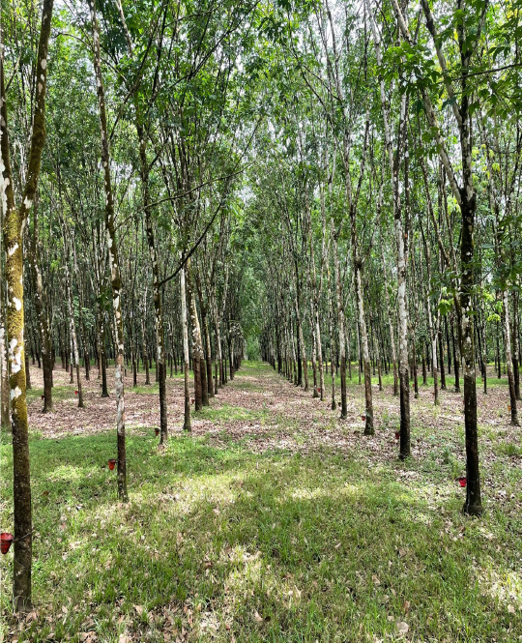

WHO ARE WE?

# [Firestone Natural Rubber](/about-us/)

Firestone Natural Rubber has been a trusted partner of the people and country of Liberia for more than 90 years. The company makes unparalleled contributions to the economic and social development of the country, leading Liberia’s private sector in employment, education, and healthcare opportunities for thousands of its citizens.

[Learn More About Us](/about-us/)

## FAST FACTS

Economy

## Investment in the Liberian Economy

Investment exceeding US $2.0 billion since 2003

Employment

## Sustainable Local Employment

More than 4,000 teammates – 99.7% of whom are Liberian

Development

## Providing Social Development

Free healthcare and education for thousands

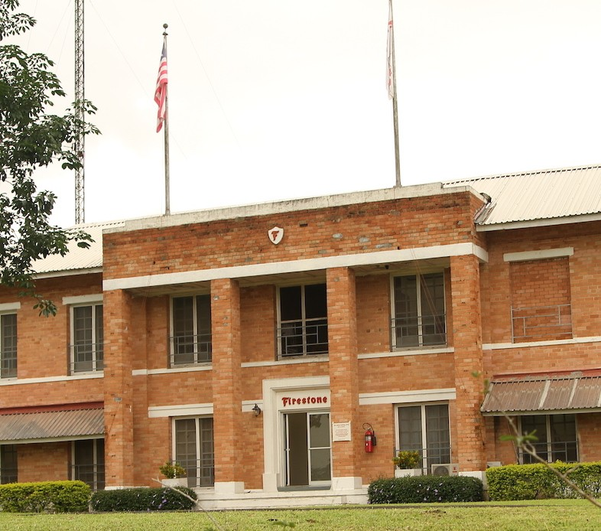

## [About Us](/about-us/)

Firestone Liberia traces its roots in the country of Liberia to the early 20th century, when an exploratory group from the Firestone Tire and Rubber Company went in search of a location to grow and process natural rubber for the purpose of tire manufacturing. The company entered into its first agreement with the Government of Liberia in 1926. Today, Firestone Liberia LLC is a legally registered company in Liberia, a direct subsidiary of Firestone Natural Rubber Company, and an indirect subsidiary of Bridgestone Americas – part of the Bridgestone Group. As one of the the country’s largest private employers, Firestone Liberia is making vital contributions to the health and wellbeing of Liberian society with a strong focus on economic opportunity, education, health, human rights and critical environmental protections.

[About Us](/about-us/)

## Featured News

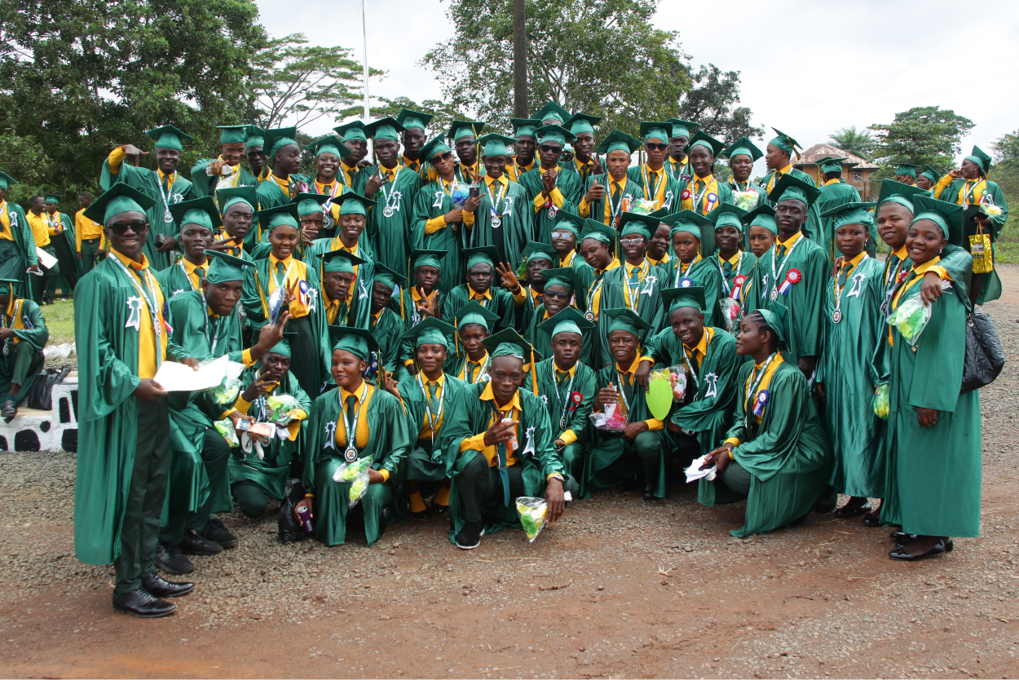

Newsroom

Wed September 7, 2022

### [Firestone Liberia Graduates 206 Senior High School Students](/articles/2022/firestone-liberia-high-school-graduation/)

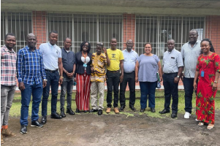

Newsroom

Mon August 1, 2022

### [Firestone Liberia Welcomes Nine New Teammates at Staff Onboarding Initiative](/articles/2022/firestone-liberia-welcomes-nine-new-teammates/)

teaser

Newsroom

Mon August 1, 2022

### [Firestone Liberia Introduces “Back to the Farm” Radio Show on Voice of Firestone](/articles/2022/firestone-liberia-introduces-radio-show/)

[See All News](/newsroom/)

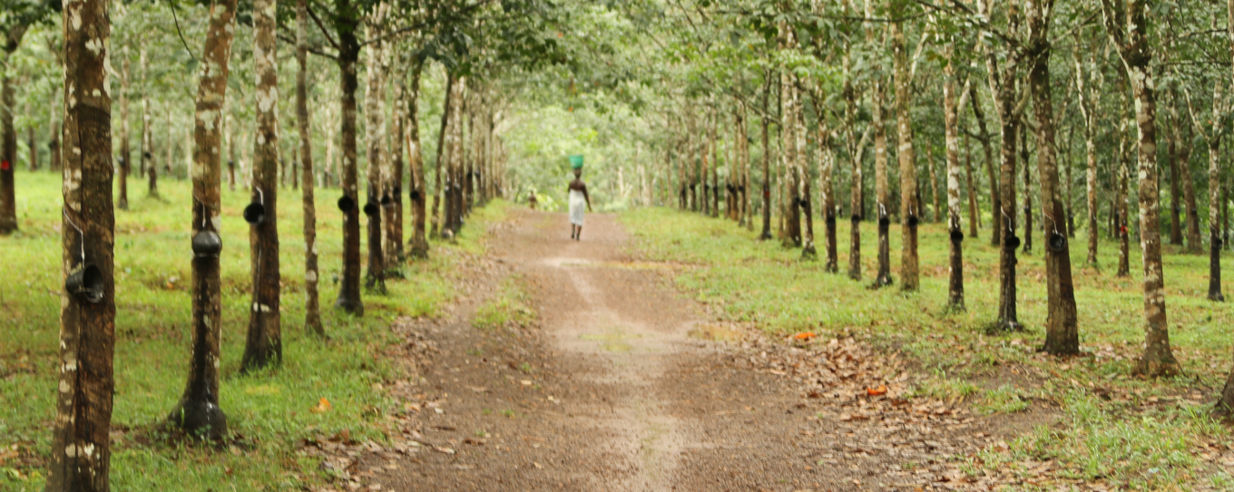

## [Our Commitment to Sustainability](/sustainability/sustainable-rubber/)

Firestone Natural Rubber is proud of its enhanced environmental stewardship policies and procedures. The company’s commitment to the environment is reflected in the comprehensive Environmental Management Plan (EMP).

First established as part of a 2005 agreement with the Government of Liberia, the EMP continues to serve as Firestone Liberia’s daily guide for enhanced and improved environmental stewardship, as well as for safe and environmentally sound operational practices.

[Our Commitment](/sustainability/sustainable-rubber/)

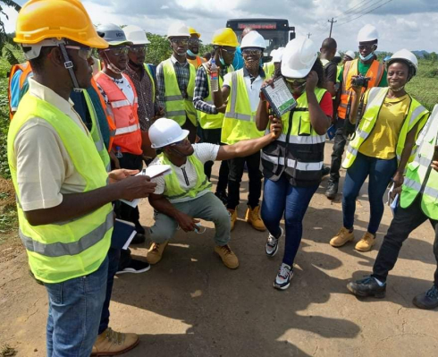

## [Investing in the Liberian Community](/social-impact/)

Firestone Natural Rubber has been a trusted partner of the people and country of Liberia for more than 90 years. The company makes unparalleled contributions to the economic and social development of the country, leading Liberia’s private sector in employment, education, and healthcare opportunities for thousands of its citizens.

[See How](/social-impact/)

## OUR SCHOOLS

Firestone Natural Rubber runs the largest concession-operated school system in the country

## 24

Schools with >7,000 students

## 100%

Children of

Teammates

## Zero

Cost to Attend

Classes

[More About Education](/social-impact/education/)

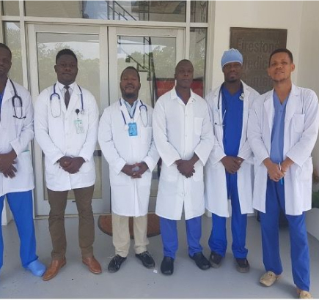

## [Healthcare](/social-impact/healthcare/)

Firestone Health Services, which includes a full-service referral hospital with 300 beds at Duside and two regional clinics operated as part of its fully funded community infrastructure, holds a “Level 2 Training Hospital” grading from the Liberian government’s Ministry of Health. This certification allows Firestone to train health practitioners such as doctors, nurses, pharmacists, laboratory technicians, anesthetists and other health professionals.

[More About Healthcare](/social-impact/healthcare/)

Firestone Natural Rubber Company

* [Terms of Use](/legal/terms-of-use/)
* [Privacy Policy](/legal/privacy-policy/)
* [Accessibility Statement](/legal/accessibility-statement/)

©2022 Firestone Liberia, LLC All rights reserved.

This site uses cookies to enhance your user experience. By continuing to browse our website, you agree to use these cookies. For more information on what cookies we use and how to manage these cookies please visit our [Privacy policy](/legal/privacy-policy/)

Accept